**Seasonal effect**

Looking at the season change in the graphs for both intra day or interday we definitely see a price hike in **Nov & Dec** compared to other months.

**2018**

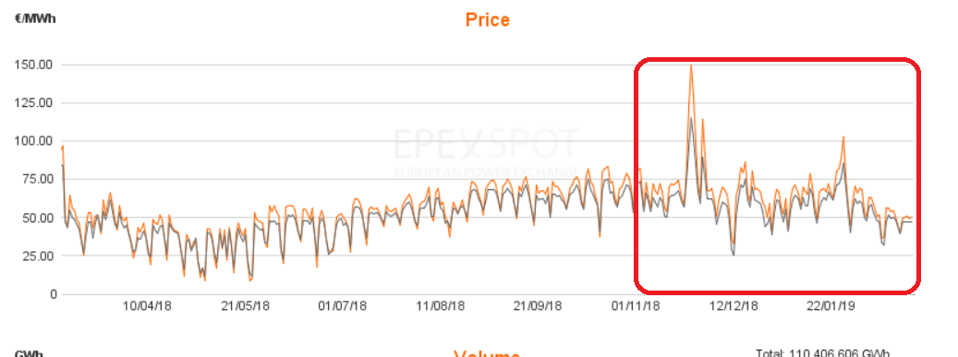

**2017**

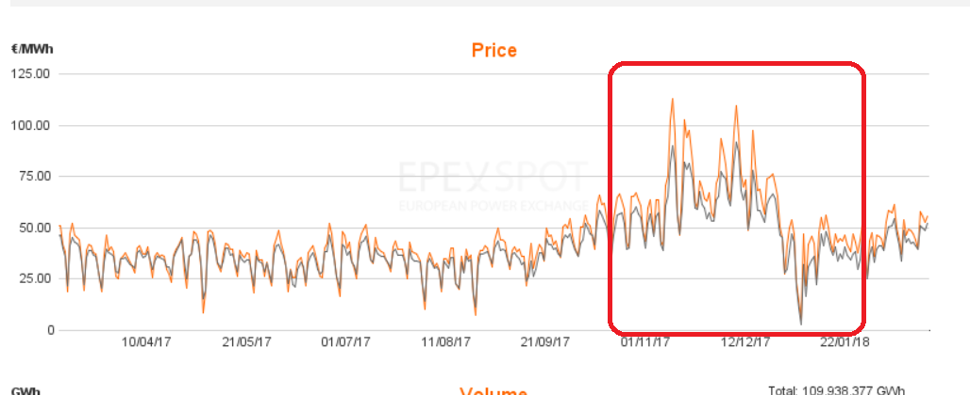

**2016**

